Using AWS Glue ETL jobs for Data migration from MongoDB to AWS Data Warehouse Redshift

**About Convosight**

**About Challenge**

DayToDay Health India (DTDHI), the Indian arm of MIT-headquartered global leader in acute care space, announced today announced that it is extending its footprint in the state of Gujarat by partnering with the Vadodara’s renowned name in cardiology care.

With its remote patient experience and care programs, DTDHI aims at enabling heart-patients with the new-age technologies in remote healthcare. It also enables and promotes the comprehensive remote handling of the infected patients from the comforts of their homes.

DTDHI is growing in business so it needs a robust, more secure and easily accessible and developer friendly system. So, DTDHI is in place to bring all its existing Services like PostgresSQL to be migrated to cloud platforms like AWS(Amazon Web Services). Currently they are using Hevo for automating the data pipeline

from MongoDB to PostgresSQL, but it is facing delays in ingestion and parallel processing.

The data is kept in MongoDB in the form of 52 tables. The data formats are String, Map, List and String Set etc. Currently PostgresSQL is being used for data warehousing. It creates relational tables based on data types in MongoDB. It also creates a sub table. A job runs after every 2 hours and the differential data from MongoDB is inserted into relational mapping of tables. But in PostgresSQL the data ingestion slows down as volume increases.

The major challenges we faced:

* support complex data types like list-of-strings (Creation of sub tables for these lists)
* support Schema changes (Addition of new columns at MongoDB side)
* Migration of heavy table(few tables are 130GB-140GB) and 7GB incremental

**AWS Services used**

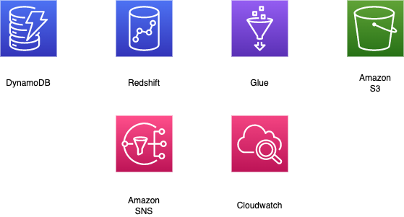

**Proposed Solution**

MIND team analyzed the problem and associated data and proposed ETL solution. Data is ingested from MongoDB, transformed to suitable form so that it can be written to Redshift(dc2.large, 2 nodes, 320 GB). This migration is a two-step process. The first step includes total migration of data up to date. The second step involves incremental data migration which runs four times a day on daily basis. The major transformation consists of casting to Redshift compatible datatype and breaking down complex MongoDB datatype to simple scalar datatype for Redshift.

* Connection is established between MongoDB and Redshift using Glue connection.
* Glue scripts takes up the MongoDB data, converts it into dynamic data frame and does the following transformation.
* In the transformation function all string are trimmed. All null datatype as casted to String datatype. All struct or map datatype are flattened.
* Any list datatype is unpacked and made into separate child table.
* The child table is referenced using a hash created from partition key and sort key.
* CDC data is filtered on the basis of max created/updated time on last job run.

**Solution Outcome**

* Migrated all table along with sub tables for list datatype
* All table will support schema change in case of addition of new column to MongoDB.
* All heavy table were migrated with CDC job set-up running twice a day
* Remaining tables were set-up with CDC jobs running four times a day.
* The data ingestion rate is now improved by 30 percent, hence leading to increased query rate.

**Architecture Diagram**

**How AWS services helped in building ETL pipeline**

**AWS Glue for ETL processing**

AWS Glue is managed ETL service for data transformation and data ingestion and in this solution all the major transformations are done using Glue ETL scripts.

**Amazon Redshift for data warehousing**

Redshift is a fully managed, petabyte-scale data warehouse which is used to store the processed data from MongoDB.

**CloudWatch for monitoring**  
Amazon CloudWatch is a monitoring and observability service which keeps a tab on the set of services being used in the form of logs, metrics, and events.

**Amazon SNS for notifying failure or timeout of Glue job**

Amazon Simple Notification Service (Amazon SNS) is a managed service that provides message delivery from publishers to subscribers (also known as *producers* and *consumers*). Here, any job failure or timeout is intimated on mail using SNS**.**

**Amazon S3 for storage**

Amazon S3 is used to store the config file which will be used by the Glue jobs. The S3 Bucket is also used here to store the status report and temporary files created by the glue jobs, this helps in tracking the status of job completion and match the row counts.

**About the Partner**

**MothersonSumi INfotech &Designs Ltd.**

MothersonSumi INfotech & Designs Limited (MIND), a SEI CMMI Level 5 IT services company and the IT back bone of Motherson group. MIND is a trusted technology partner to over 200 clients globally. Our value proposition is in our strength in specific Industry segments and years of experience in the areas of intelligent warehousing, Supply chain enablement, software application development, smart ERP customization, infra managed services, cloud, IoT & Analytics. MIND is serving customers in 41+ countries with a strong team of 1500+ professionals.